EXPERIMENT –2

**EXPERIMENT 2:**

**Perform data preprocessing tasks and Demonstrate performing association rule mining on data sets**

* 1. **Explore various options available in Weka for preprocessing data and apply (like Discretization Filters, Resample filter, etc.) on each dataset**

**Aim:** Explore various options available in Weka for preprocessing data and apply (like Discretization Filters, Resample filter, etc.) on each dataset

**Dataset:**

@relation weather

@attribute outlook {sunny,rainy,overcast}

@attribute temparature numeric

@attribute humidity numeric

@attribute windy {true,false}

@attribute play {yes,no}

@data

sunny,85.0,85.0,false,no

overcast,80.0,90.0,true,no

sunny,83.0,86.0,false,yes

rainy,70.0,86.0,false,yes

rainy,68.0,80.0,false,yes

rainy,65.0,70.0,true,no

overcast,64.0,65.0,false,yes

sunny,72.0,95.0,true,no

sunny,69.0,70.0,false,yes

rainy,75.0,80.0,false,yes

**Procedure:**

* + 1. For preprocessing the data after selecting the dataset (weather.arff).
    2. Select Filter option & apply the resample filter & see the below results.

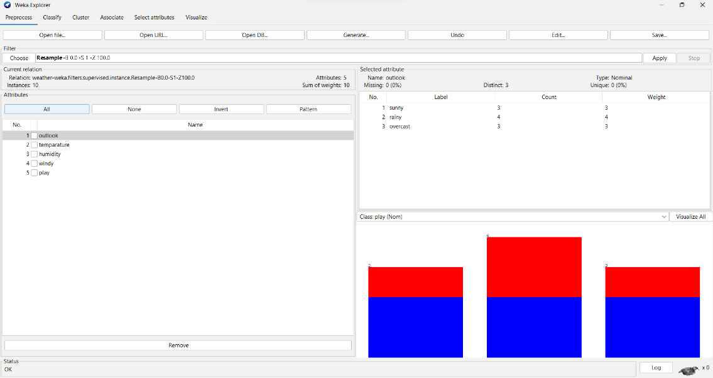

1. Select another filter option & apply the discretization filter, see the below results

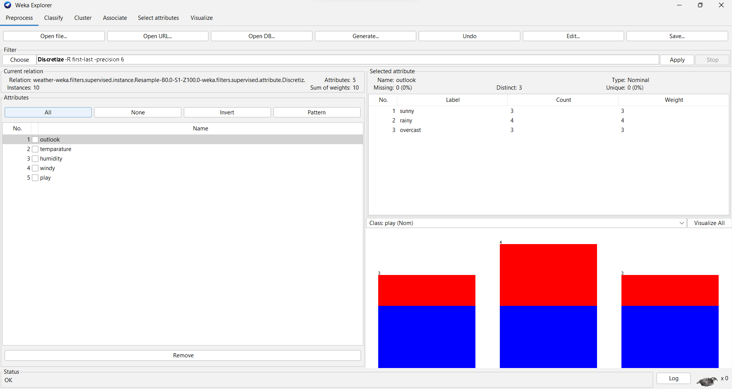

Likewise, we can apply different filters for preprocessing the data & see the results in different dimensions.

# Load each dataset into Weka and run Apriori algorithm with different support and confidence values. Study the rules generated.

@relation contact-lenses

@attribute age {young, pre-presbyopic, presbyopic}

@attribute spectacle-prescrip {myope, hypermetrope}

@attribute astigmatism {no, yes}

@attribute tear-prod-rate {reduced, normal}

@attribute contact-lenses {soft, hard, none}

@data

young,myope,no,reduced,none

young,myope,no,normal,soft

young,myope,yes,reduced,none

young,myope,yes,normal,hard

young,hypermetrope,no,reduced,none

young,hypermetrope,no,normal,soft

young,hypermetrope,yes,reduced,none

young,hypermetrope,yes,normal,hard

pre-presbyopic,myope,no,reduced,none

pre-presbyopic,myope,no,normal,soft

pre-presbyopic,myope,yes,reduced,none

pre-presbyopic,myope,yes,normal,hard

pre-presbyopic,hypermetrope,no,reduced,none

pre-presbyopic,hypermetrope,no,normal,soft

pre-presbyopic,hypermetrope,yes,reduced,none

pre-presbyopic,hypermetrope,yes,normal,none

presbyopic,myope,no,reduced,none

presbyopic,myope,no,normal,none

presbyopic,myope,yes,reduced,none

presbyopic,myope,yes,normal,hard

presbyopic,hypermetrope,no,reduced,none

presbyopic,hypermetrope,no,normal,soft

presbyopic,hypermetrope,yes,reduced,none

presbyopic,hypermetrope,yes,normal,none

**Procedure:**

* + 1. Load the dataset (contact-lenses.arff) into weka tool
    2. Go to associate option & in left-hand navigation bar we can see different association algorithms.
    3. In which we can select Aprori algorithm & click on select option.
    4. Below we can see the rules generated with different support & confidence values for that selected dataset

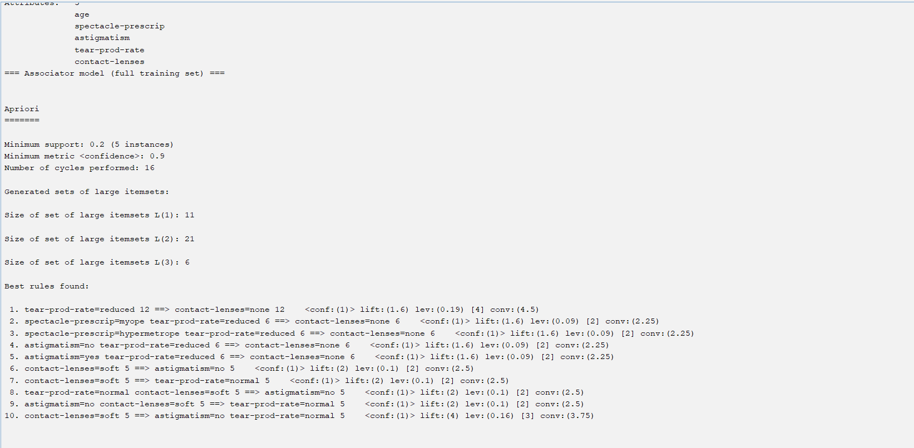

# Apply different discretization filters on numerical attributes and run the Apriori association rule algorithm. Study the rules generated. Derive interesting insights and observe the effect of discretization in the rule generation process.

**Procedure:**

1. Load the dataset (contact-lenses.arff) into weka tool& select the discretize filter & apply it.
2. Go to associate option & in left-hand navigation bar we can see different association algorithms.
3. In which we can select Aprori algorithm & click on select option.
4. Below we can see the rules generated with different support & confidence values for that selected dataset.

